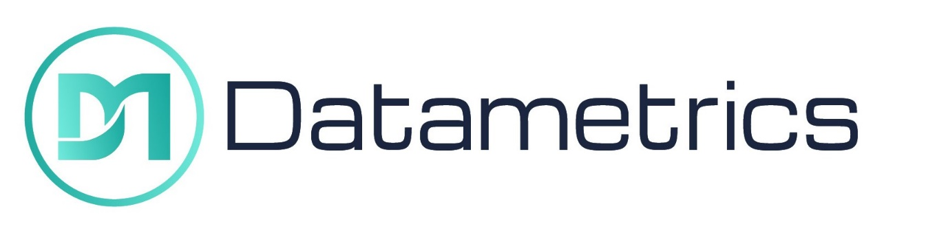
Datametrics Limited
Modern Slavery and Human Trafficking Policy Statement
Document control.
Document no | PD/32
Author | R Pannell
Owner | R Pannell
Distribution | All staff
Document Status | Final version for distribution
Revision history
Version | Date | Description | Author
5.0 | 31/03/2024 | Annual Review | R Pannell
6.0 | 03/01/2025 | Annual Review | R Pannell
7.0 | 01/10/2025 | Re-branding/Annual Review | P Ranger
Reviewer list
Name | Role
R Hughes | Operations Director
Approvals
Name | Signature | Title | Date of issue | Version
R Pannell | R Pannell | Director | 01/10/2025 | 7.0

Contents
1.0 Organisation 3
2.0 Organisational Structure 3
3.0 Definitions 3
4.0 Commitment 3
5.0 Supply Chains 3
6.0 Potential Exposure 4
7.0 Steps 4
8.0 Key Performance Indicators 5
9.0 Policies 5
10.0 Training 5
11.0 Slavery Compliance Officer 5

Organisation
This statement applies to Datametrics Installation Services Limited (referred to in this statement as ‘DM’). It outlines DM's approach to ensuring compliance with the Modern Slavery Act 2015 for the financial year 2024/2025.

- Organisational Structure
DM works predominately across the whole of the United Kingdom. The company operates on a regional basis and overall control is served by the main office which is in Northamptonshire. Local regions are served by remote workers. The company specialises in Datametrics Installation Services specialises in providing comprehensive technology infrastructure solutions, including network cabling, telecommunications system setup, security systems integration, smart building installations, and electrical support for IT systems. We also offer customised solutions, diagnostics, and maintenance to ensure reliable and efficient operations tailored to residential, commercial, and industrial needs with workforce and materials sourced both locally and globally based on project requirements.
Work is carried out on a client lead, project specific, contractual basis across the regions. This means that project locations are highly transient and include projects overseas. Therefore, the labour supplied to DM in pursuance of its operation is carried out mainly across the United Kingdom but does include other countries across the world.

- Definitions
DM considers that modern slavery encompasses:
- Human trafficking.
- Forced work, through mental or physical threat.
- Being owned or controlled by an employer through mental or physical abuse of the threat of abuse.
- Being dehumanised, treated as a commodity or being bought or sold as property.
- Being physically constrained or having restrictions placed on freedom of movement.

- Commitment
DM acknowledges its responsibilities in relation to tackling modern slavery and commits to complying with the provisions in the Modern Slavery Act 2015. DM understands that this requires an ongoing review of both its internal practices in relation to its labour force and, additionally, its supply chains.
DM does not enter business with any other organisation, in the United Kingdom or abroad, which knowingly supports or is found to involve itself in slavery, servitude and forced or compulsory labour.
No labour provided to DM in the pursuance of the provision of its own services is obtained by means of slavery or human trafficking. DM strictly adheres to the minimum standards required in relation to its responsibilities under relevant employment legislation in the United Kingdom, and in many cases exceeds those minimums in relation to its employees.

- Supply Chains
To fulfil its activities, DM’ main supply chains include those related to the supply of construction materials and labour. These are predominately within the UK and therefore are subject to UK legislation. Operating overseas means that some of our supply chains are made up of local materials and labour, however this is highly dependent on client requirements, availability of local skills and quality of local materials. All of our UK Supply chain is required to sign a code of conduct which sets out DM’ core values and standards of behaviour.
The code is in line with and exceeds the current legislative compliance and moral societal thinking. Our supply chain is in essence fluid as it changes upon what region, office or project is covered, and additionally on occasion our supply chain is prescribed by the client’s request. We constantly monitor our supply chain through supply chain audits and management performance reviews.

- Potential Exposure
DM considers its main exposure to the risk of slavery and human trafficking to exist from imported construction materials from sources outside the UK and EU, through suppliers where DM undertakes work along with its overseas construction works, particularly in developing countries. It is recognised that this is a sector that is more likely to engage in this type of practice and countries outside of the UK are potentially more likely to partake in slavery/human trafficking issues as protection against breaches of human rights may be limited.
In general, DM considers its exposure to slavery/human trafficking to be relatively limited, nonetheless, it has taken steps to ensure that such practices do not take place in its business nor the business of any organisation that supplies goods and/or services to it.

- Steps
DM carries out due diligence processes in relation to ensuring slavery and/or human trafficking does not take place in its organisation or supply chains, including conducting a review of the controls of its suppliers.
DM has not, to its knowledge, conducted any business with another organisation which has been found to have involved itself with modern slavery.
In accordance with section 54(4) of the Modern Slavery Act 2015, DM has taken the following steps to ensure that modern slavery is not taking place:
- Board level commitment to the implementation of the Modern Slavery and Human Trafficking policy
- The supplier approval process will incorporate a review of the controls undertaken by them prior to them being included on the preferred suppliers list
- Monitoring as part of the Contractor Assessment process and when working overseas as part of the Contractual arrangements agreed
- Zero tolerance, DM will not support or deal with any business knowingly involved in slavery or human trafficking
- Developing and implementing codes of conduct in line with DM values and societal moral values
- Providing training, posters, awareness material and guidance on recognising modern slavery
- Working with overseas clients who share similar values to evaluate local labour and material suppliers
- Carrying out supply chain audits
- Implement and embed an open door speak up philosophy throughout the business
- Key Performance Indicators
DM has set the following key performance indicators to measure its effectiveness in ensuring modern slavery is not taking place in DM or its supply chains.
- Zero occurrences of modern slavery through supplier audits
- All staff trained in modern slavery
- Internal audit findings

- Policies
DM has the following policies which further define its stance on modern slavery
- Ethical Purchasing Policy Statement
- Subcontractor & Supplier Code of Conduct
- Recruitment and Selection Policy
- Modern Slavery and Human Trafficking Policy Statement

- Training
DM provides the following training to staff to effectively implement its stance on modern slavery. Initial Training is via company introduction, review and the staff handbook.
Ongoing training is undertaken in the form of toolbox talks, awareness posters and supply chain school videos.
https://www.supplychainschool.co.uk/default/modern-slavery.aspx
https://www.supplychainschool.co.uk/uk/fir/construction/default.aspx
We also download a variety of posters in various languages from the Government website.
https://www.gov.uk/government/publications/modern-slavery-closer-than-you-think

- Slavery Compliance Officer
All employees, sub-contractors and suppliers for DM act as Slavery Compliance Officers, all concerns regarding modern slavery should be addressed via email to the DM compliance team at compliance@datametrics.co.uk ,who will then undertake relevant action with regard to DM obligations.
This statement is made in pursuance of Section 54(1) of the Modern Slavery Act 2015 and will be reviewed for each financial year.

DATED: 01/10/2025

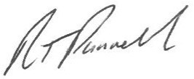
SIGNED:

DIRECTOR: Datametrics Installation Services Ltd

